PERVASIVE COMPUTING

UNIT-1

Defination:-

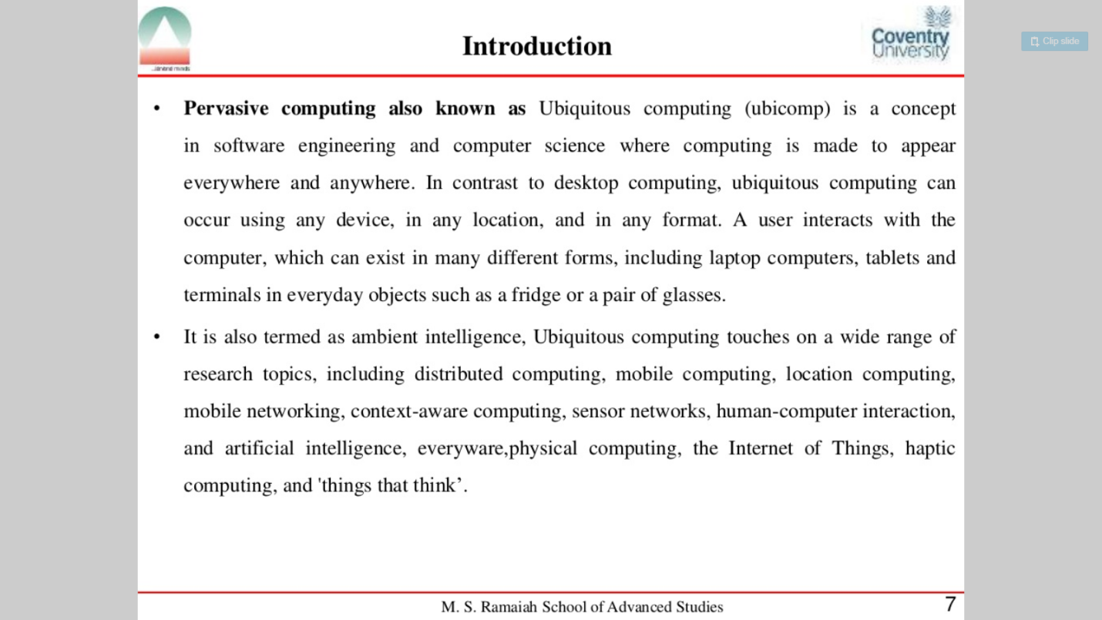

Principles of pervasive:

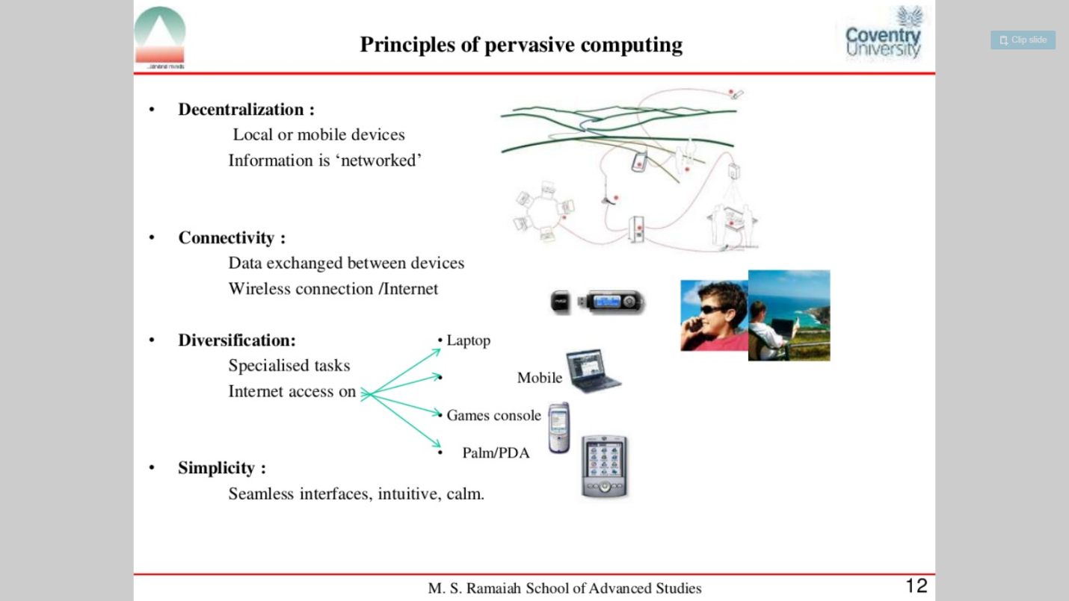

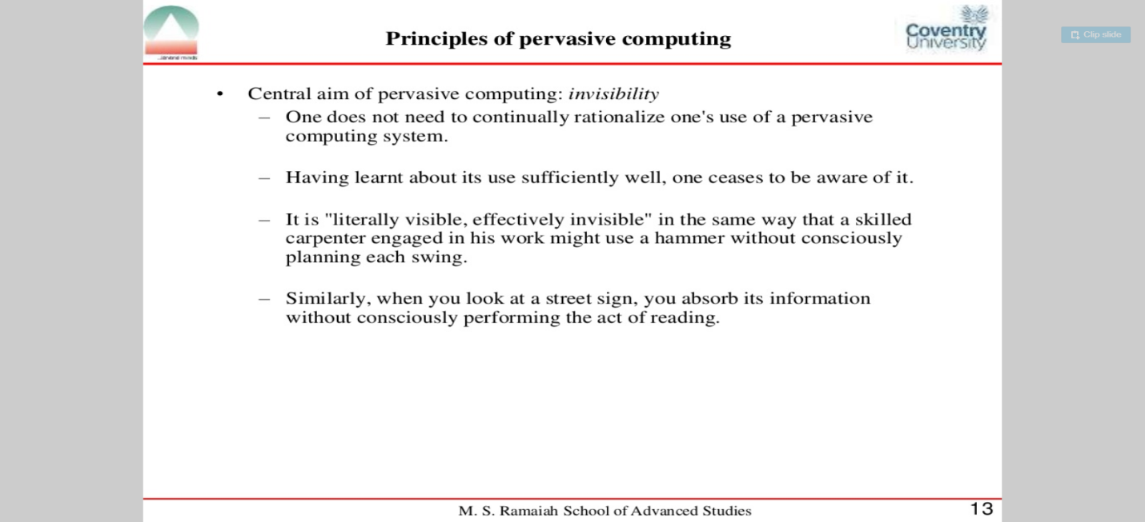

Characteristics of pervasive: 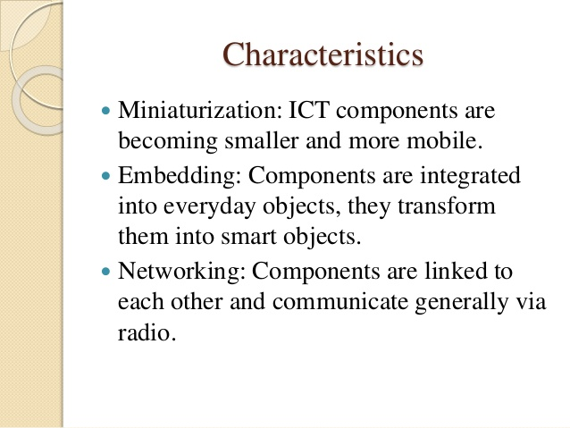

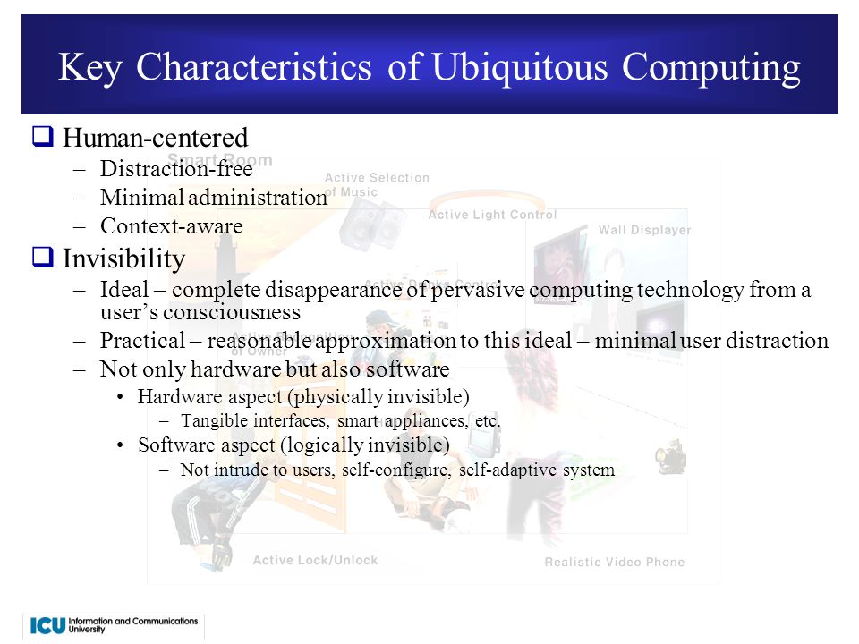

Applications of pervasive:-

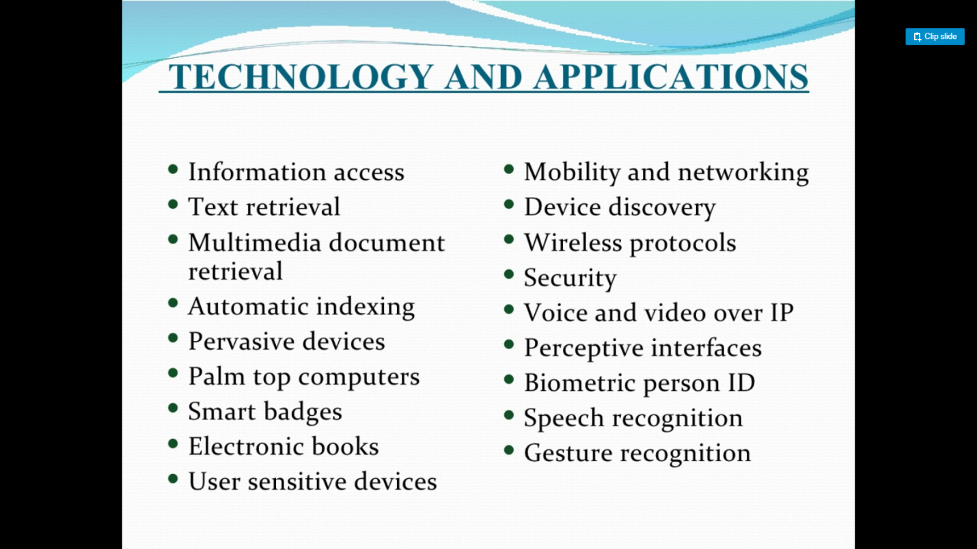

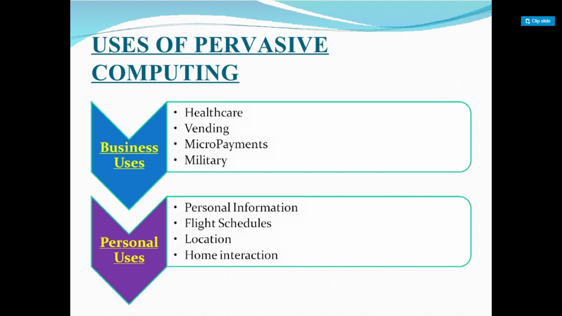

1. Retail
2. Airline check-in and booking
3. Sales force automation
4. Healthcare
5. Tracking
6. Car information system
7. Email access via WAP and voice

Pervasive devices:

1. Hardware
   1. Batteries
   2. display
   3. memory
   4. processors
2. Human-machine interface
   1. Navigation
   2. Haptic interface
   3. Keyboards
   4. Hand writing recognition
   5. Speech recognition
3. Biometrics
4. Operating system
   1. Palm os
   2. Windows CE
   3. Embedded linux

Protocols:

1. Wireless protocols
   1. WAP/WML
   2. OBEX
2. Mobile phone technology
   1. 1g
   2. 2g
   3. 2+G
   4. 3g
   5. 4g
3. Mobile internet protocol

Architecture of pervasive:

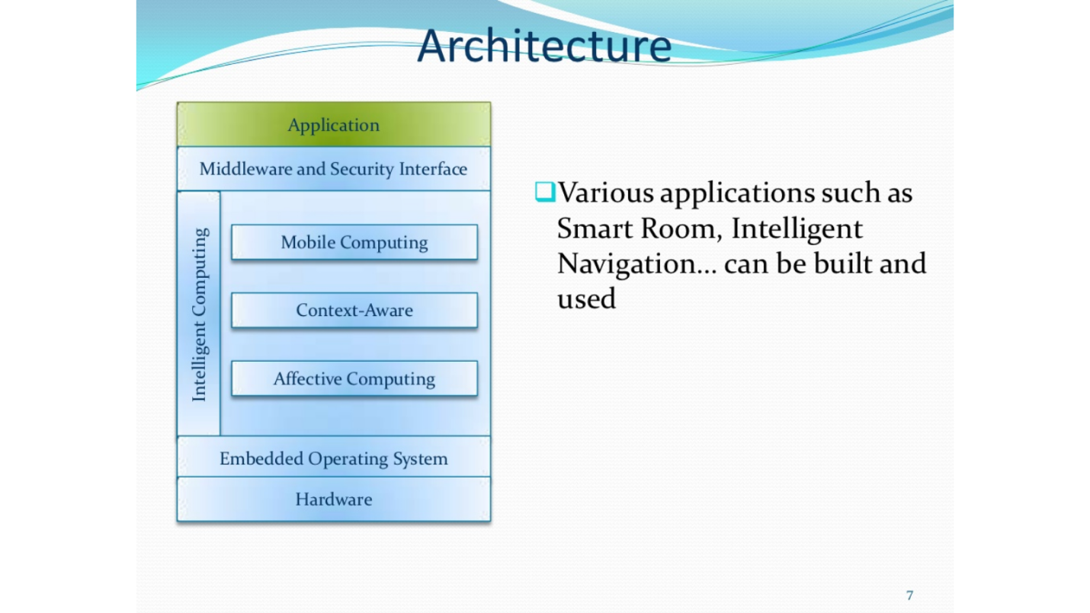

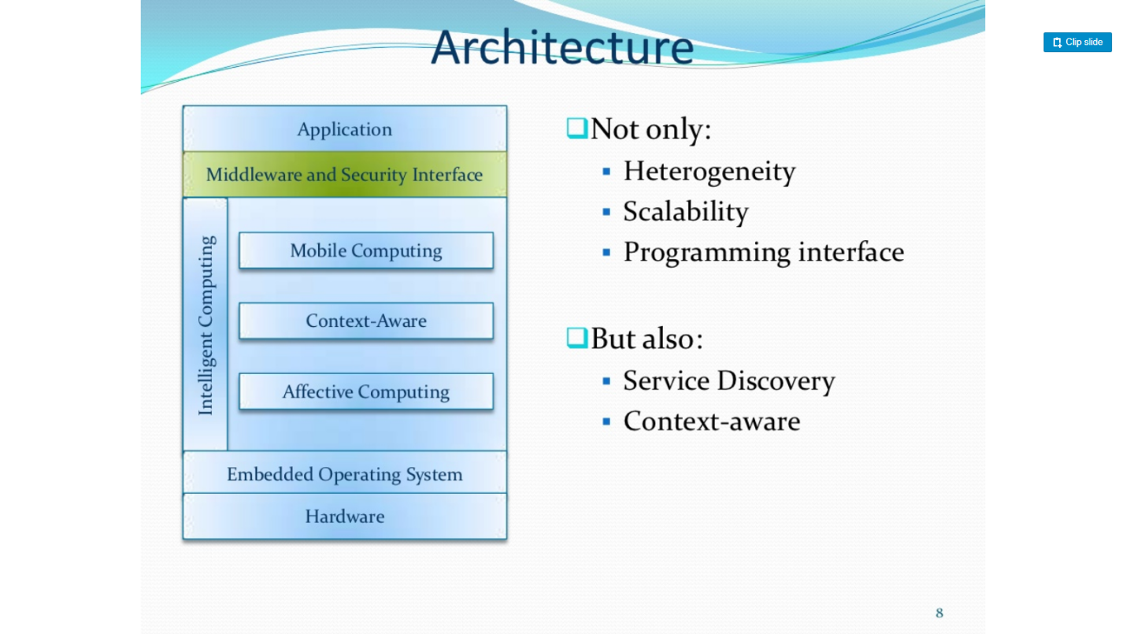

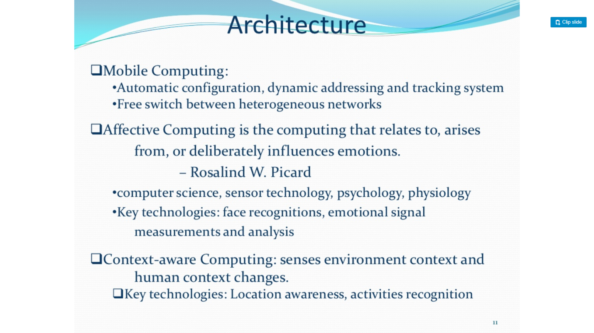

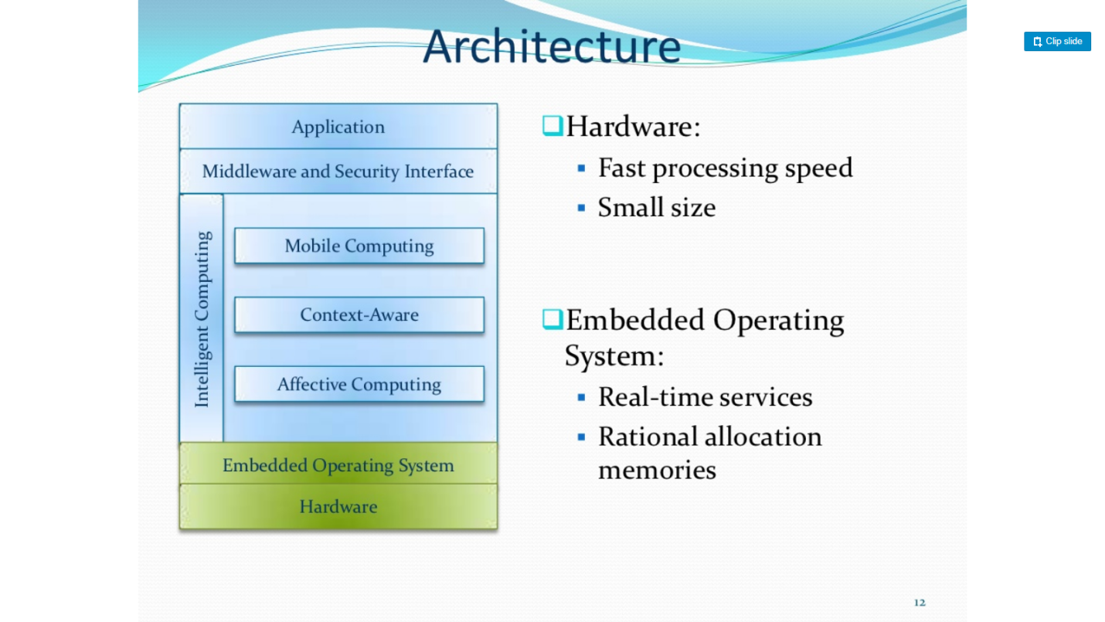

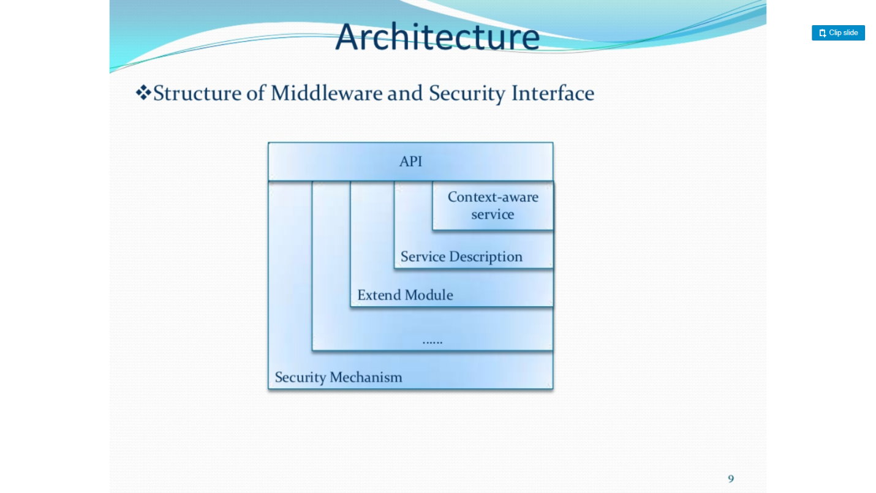

Interaction trasparancy:

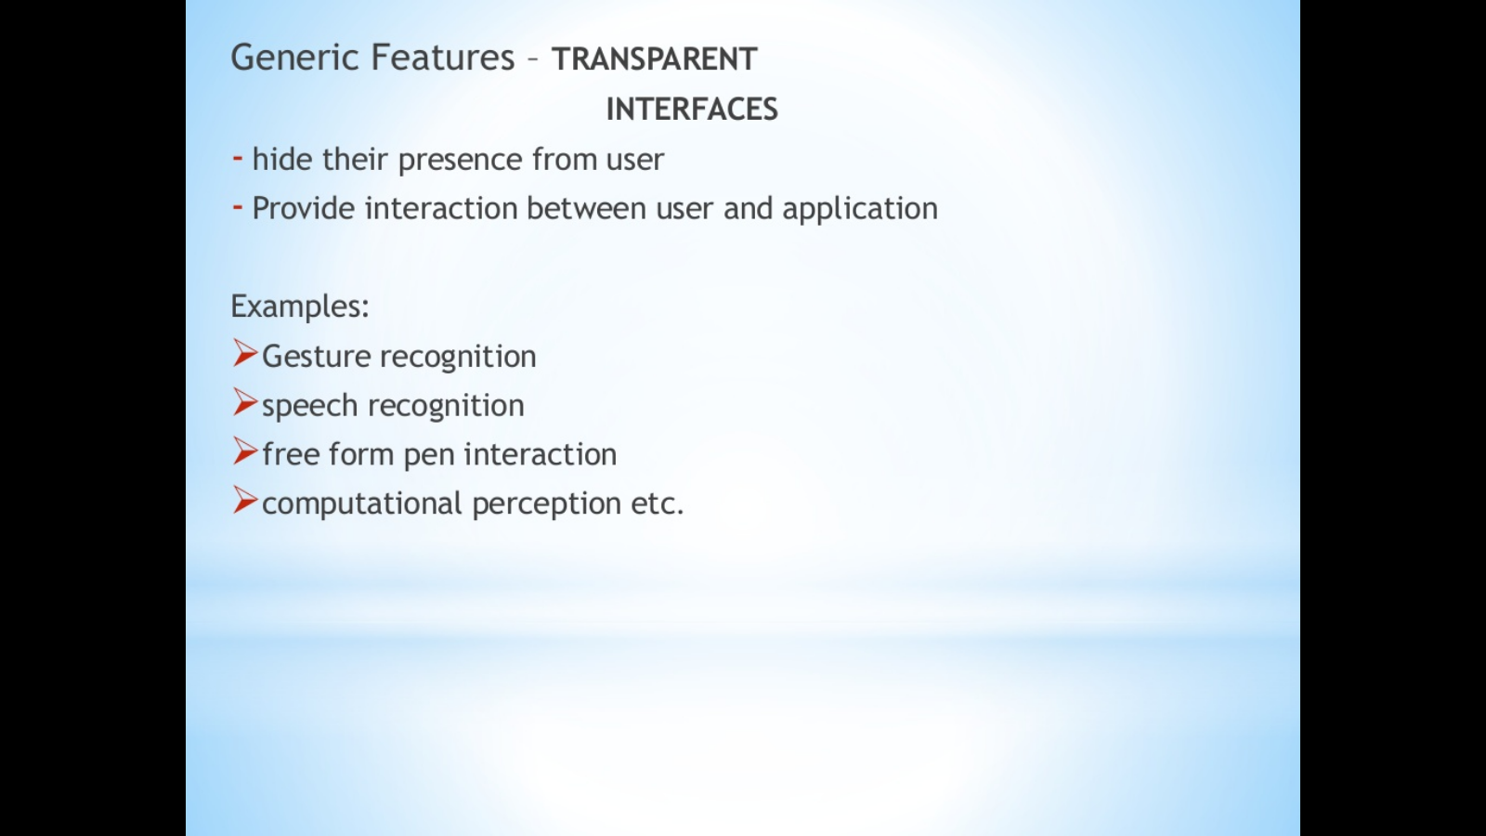

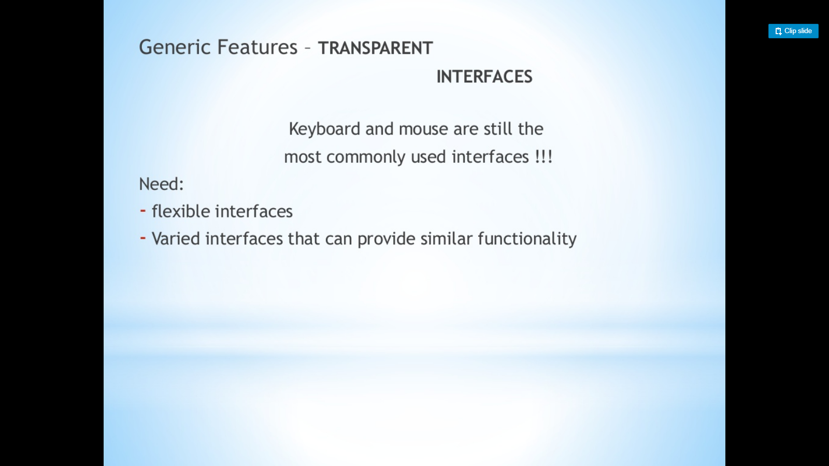

Context awareness:

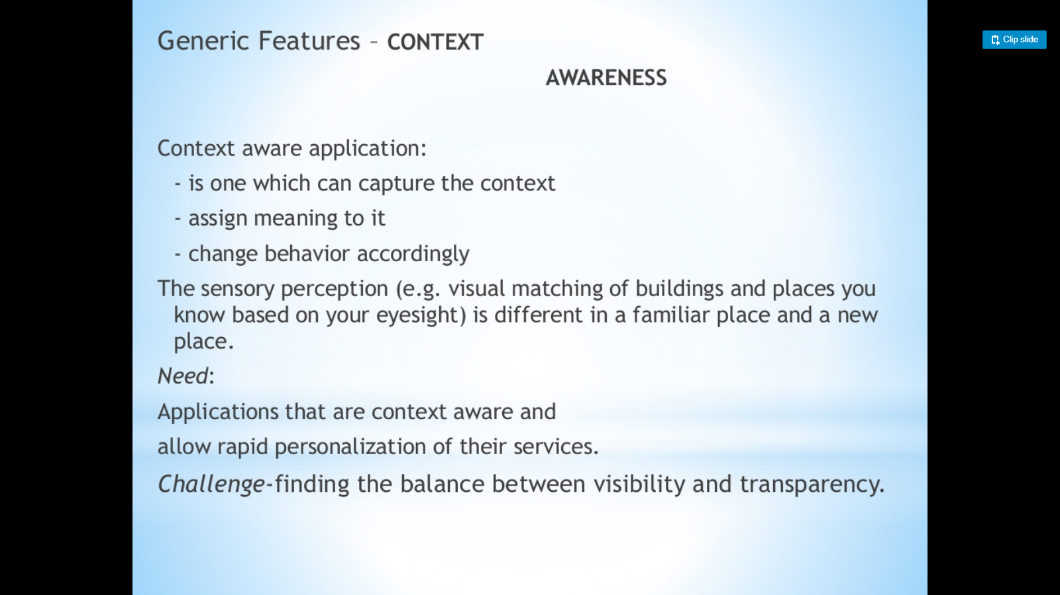

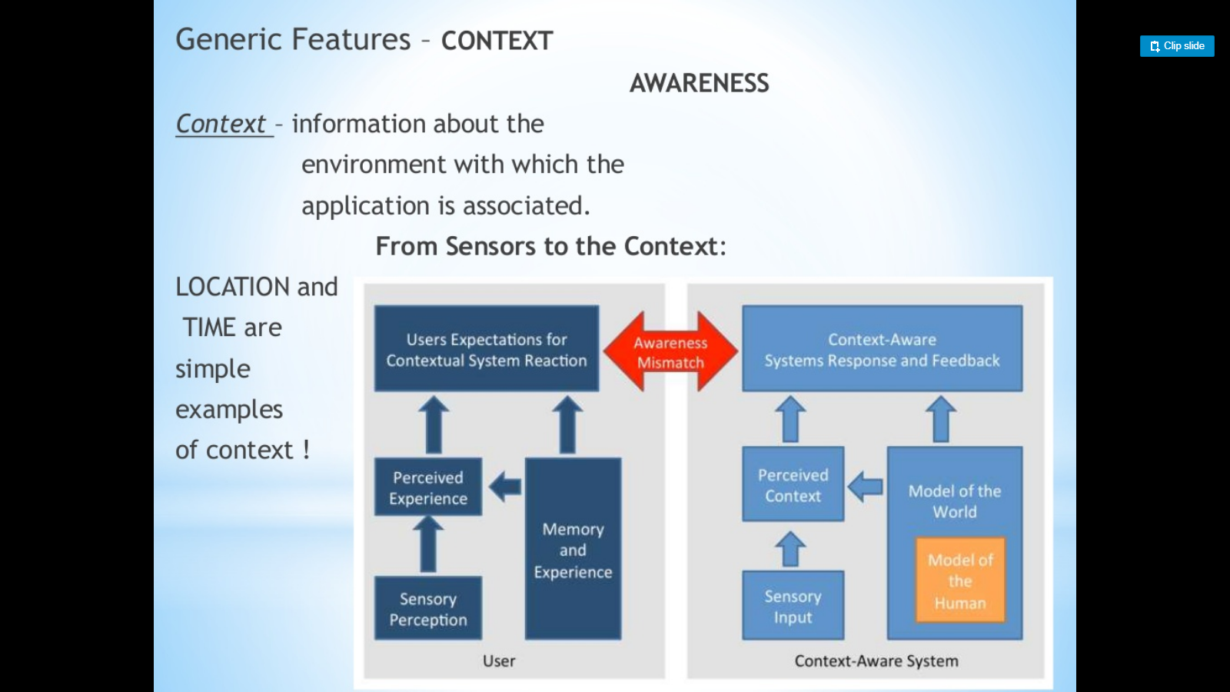

Automated experience capture:

